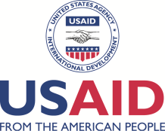 | 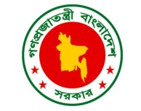
SHOUHARDO II
Program Closing Report
Implementation Period: March 2011 to February 2015
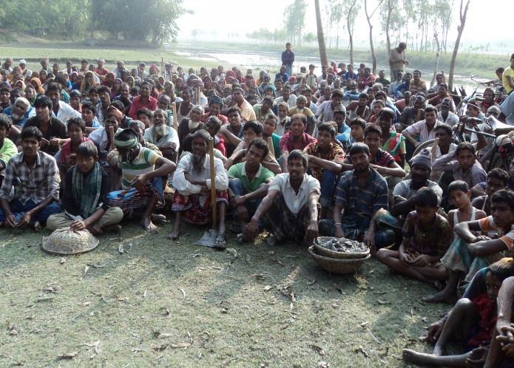

Implemented by:
SOLIDARITY
Address: New Town, Kurigram
Cell phone: 01715169469
Fax: 058161789 (on request)
E-mail: solidarity_bd@yahoo.com

Credit Page

Report Prepared by:
Most. Tarzina Khatun, Program Manager,
SHOUHARDO II Program, SOLIDARITY.

Edited by:
S.M Harun Or Rahid Lal
Executive Director, SOLIDARITY
Md. Kamal Pasa, Asst. Professor,
Dept. of Anthropology,
Rajshahi University, Rajshahi.

Data and Graph prepared by:
Md. Samiul Alam, TO (A&L), SHOUHARDO II Program, SOLIDARITY
Ms. Sahanaz Begum, TO-HHN, SHOUHARDO II Program, SOLIDARITY
Kolpona Ray, TO-Empowerment, SHOUHARDO II Program, SOLIDARITY
Ms. Mahfuja Akterbanu, TO-IB, SHOUHARDO II Program, SOLIDARITY
Ms. Jannati Akter, TO-DRR, SHOUHARDO II Program, SOLIDARITY
Md. Ali Hossain, Infrastructure Officer, SHOUHARDO II Program, SOLIDARITY
Md. Abdul Malek, TO (M&E), SHOUHARDO II Program, SOLIDARITY

Financial Information by:
Ms. Sumana Islam
Finance & Admin Officer
SHOUHARDO II Program, SOLIDARITY.

Cover Design by:

SHOUHARDO II Program Team
SOLIDARITY

Report Printed by:
Susmita Computer, Kurigram

Note from the Executive Director
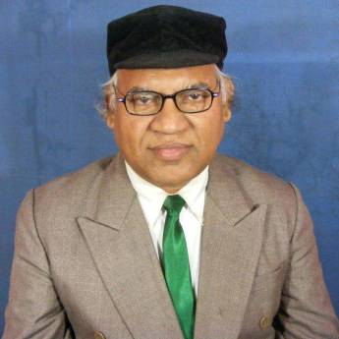
I am pleased and proud for the successful completion of ‘SHOUHARDO II Program in Kurigram Sadar Upazila as Partner of CARE as per memorandum of understanding with CARE Bangladesh covering the period from March 2011 to February 2015. With the financial assistance of USAID and Government of Bangladesh, the SOLIDARITY as an implementing partner of CARE Bangladesh implemented a series of community driven activities under all 5 strategic objectives with a view to reduce vulnerability to food insecurity and enhancement of livelihoods with 16562 poor and extreme poor households of 49 villages of Kurigram Sadar Upazila under Kurigram district.
For securing the food availability, accessibility, utilization and stability SHOUHARDO II Program extended its full effort and performed almost all the planned activities with all necessary technical support from CARE Bangladesh, involved government departments and all other stakeholders to whom SOLIDARITY is indebted. With positive and active participation of the diverse stakeholders such as community members, CBOs, VDCs, EKATAs, ECCDs, duty bearers and government institutions, technical partners and supportive supervision and monitoring of CARE Bangladesh, we provided immense efforts with effective governance in delivering quality program activities to reach objectives of the program. The CARE’s innovative initiative of quality improvement visit was a mile stone for enhancing the quality at field level. Under the 5 strategic objectives set of activities were launched on agriculture, comprehensive homestead development, fisheries and IGA to 100% targeted beneficiaries besides all it cross cutting activities.
On behalf of SOLIDARITY management, I would like to extend my gratitude to CARE, GOB departments, Local administrations, members of all Union Parishads and officials associated with Upazila parishad and specially CARE regional office for their great support and assistance extended in all time for execution of interventions in achieving its complex goal. We the Solidarity team highly grateful to USAID, CARE Region and HQ and government for their timely and intellectual support toward us to accomplish the huge activities of the Program within shortest time and with quality. We should be proud of all who are involved with directly or indirectly in the program. I am extending my gratitude to my SHOUHARDO II Program team and the members of core team who supported lots and successfully completed the SHOUHARDO maintaining high quality of work. Being faced multifarious problems in different time for political reasons yet SOLIDARITY reached in to the aspirated objectives and goal of the program as an implementing partner.
The structural and monumental complex programs were successfully executed by the utilization of knowledge, talent and experiences of the people which inspired local people for movement of development. We greatly acknowledge the community members and VDCs for their depth contribution for successful completion of the SHOUHARDO II Program. Cordial thanks to those workers who contributed their labor, talent and honesty to achieve the program goal and objectives

S.M Harun Or Rahid Lal
Executive Director, SOLIDARITY

Table of Contents

Topic | Page No.
Executive Summary | 1
Introduction | 2
Program Goal and Objectives | 2
Program Location and Beneficiary Coverage | 3
Beneficiaries Covered | 3
Program Management | 4
Program Achievement and Results | 4
Commodity Distribution and Management | 15
Program Exit and Sustainability | 16
Financial Information | 17
Challenges and Lessons Learnt | 18
Conclusions | 18

Abbreviations
BINA | Bangladesh Institute of Nuclear Agriculture.
CAP | Community Action Plan
CAV | Community Agriculture Volunteer
CHD | Comprehensive Homestead Development
CHV | Community Health Volunteer
CFW | Cash for Work
COG | Core Occupational Group
CRC | Community Resource Centre
DCRM | Disaster and Climate Risk Management
ECCD | Early Childhood Care and Development
ECCDMC | ECCD Management Committee
EKATA | Empowerment, Knowledge and Transformative Action
EVAW | Ending Violence Against Women
FDP | Food Distribution Point
GA | Gender Analysis
GMP | Growth Monitoring and Promotion
GoB | Government of Bangladesh
HH | Household
HHN | Health, Hygiene and Nutrition
IDDR | International Day for Disaster Reduction
IGA | Income Generating Activity
LCS | Labor Contracting Society
LEB | Local Elected Body
LGED | Local Government and Engineering Department
LOA | Life of Award
MCHN | Mother Child Health and Nutrition
MYAP | Multi Year Assistance Program
NBD | Nation Building Departments
NDPD | National Disaster Preparedness Day.
NNPC | Nari Nirjaton Protirodh Committee
PACC | Program Advisory and Coordination Committee
PEP | Poor and Extreme Poor
PM2A | Preventing Malnutrition in Children under 2 Approaches
PNGO | Partner Non-Governmental Organization
PSE | Private Sector Engagement
RRO | Rangpur Regional Office
R&R | Risk and Resource
S&R | Search & Rescue
SBTB | School Base Teenaged Brigade
SHOUHARDO | Strengthening Household Ability to Respond to Development Opportunity
SO | Strategic Objective
UDCC | Union Disaster Coordination Committee
UDMC | Union Disaster Management Committee
UDMP | Union Disaster Management Plan
UzDMC | Upazila Disaster Management committee
USAID | United States Aids for International Development
WBA | Well-Being Analysis

Executive Summary:
The SOLIDARITY was assigned to implement the SHOUHARDO II program from March 2011 to February 2015 among the 16562 poor and extreme poor (PEP) households under Sadar Upazila of Kurigram district. The program implementation framework was community-centered. Alternatively, the VDCs, EKATAs, PICs, UDMCs and so on were the key catalyst for change with direct implementation support from the SOLIDARITY. The implementation strategy consisted of ‘capacity building, ‘assets transfer’ and infrastructural development, supports to agriculture and livelihood, health, Hygiene and Nutrition, Women and Girls’ empowerment, institutional strengthening, and disaster risk management and climate change. The performance of achievement against its planned target over the program period was close to 100% with some minor upward and downward deviation because of migration, displacement, death of HHs etc. Concerning to access availability and Utilization of nutritious foods, the organization categorized the whole primary targeted beneficiaries in to four core occupational groups such as CHD, agriculture, fisheries, and IGA.
100% COG households were provided with basic training and input support to16368 Hhs and for the second time refreshers trainings and input supports were provided to 16290 Hhs with lesser number due to migration and death etc. All Community Agriculture Volunteer (58 persons) received basic and refresher training on updated agriculture technologies and supporting techniques. Courtyard sessions were arranged with beneficiaries (27731 Session). Updated technology diffused and adopted through collaborative initiative with support from technical partners like IUCN, BINA, CSISA as well as all necessary cooperation from government agriculture department. Platform based goats rearing piloting and Varmi compost preparation and utilization was found beneficial for poor beneficiaries both economically and environmentally as action research. Secondly, through forming 29 saving groups the poor people accumulated around taka 5 lacs that helped to address the need of safety net support.
Relating to enhanced health, hygiene and nutrition promotion, the organization in collaboration with VDC, EKATA, CHV and govt. health and family planning service providers accomplished diverse activities. Knowledge and awareness sessions on MCHN were courtyard (6668 session), GMP (6507 session ) sessions, mother to mother support session (240 session ), CMAM and day observance etc were conducted with the help of CHVs and with collaborative initiatives of govt. heath and family departments. Besides, health care services, CHV capacity building and ration distribution under MCHN and PM2A have also contributed to improve maternal health, reduce child stunting and wasting and overall improvement of nutritional health among the communities. For empowering women and adolescent girls, 20 EKATA groups with 700 participants were formed that tremendously contributed for women and girl empowerment and reduce violence against women. Again, a total of 26 ECCD Centers were opened and facilitated child education of poor people and created a momentum in attending formal education. Due to multifarious program interventions and it governance through involvement of LEBs and PACC members the responsiveness and accountability enhance everywhere. Program supported training on citizen charter, life skill and leadership and so on that enhanced capacity of bargaining and decision making.
Relating to disaster risk reduction and climate change, a resilient social and material structure was built through DMC at union and Upazila level with necessary skill, risk and resource mapping, contingency plan development etc for emergency preparedness and addressing. Raising knowledge and awareness of community people on disaster and climate change issues and necessary support in this regards was helped to capacitate communities, volunteers and respective agencies. During the natural calamities the role of volunteers was commendable. However, through implementing diversified activities SOLIDARITY with assistance from CARE-Bangladesh and financial assistance of USAID and Government of Bangladesh a commendable positive change were brought in to the life and livelihoods of targeted poor people that broadly helped in achieving program goal.

1. Introduction:
SOLIDARITY is one of the leading local NGOs in northern belt working for the improvement of disadvantaged and marginalized people. SOLIDARITY established in the year 1992 with registration from- Social Welfare and is engaged in service delivery and follows rights based approach for improved life and livelihoods of disadvantaged hardcore poor people. SOLIDARITY is working in 49 villages of 8 Unions under Kurigram district with a vision of poverty free society where human rights and social justice be promoted. Local capacity building, elimination of gender discrimination and reduction of poverty etc are the main areas of work of SOLIDARITY. SOLIDARITY has been working since beginning with partnership of community, LEBs and different donors where worked with CARE Bangladesh since 1996 in ‘Flood Proofing Project’ and subsequently successfully implemented SHOUHARDO 1st phase with good reputation.

After successful accomplishment of SHOUHARDO 1st phase again SOLIDARITY was awarded further to implement the SHOUHARDO II program at 8 unions of Kurigram Sadar Upazila under Kurigram district from March 2011 to February 2015 for achieving the goal of SHOUHARDO II program and executed set of activities to transform the lives of women and men of 16872 PEP households by reducing their vulnerability to food insecurity. These households are identified following a long participatory approach. Against each strategic objective huge potential and community identified activities were targeted from the community Action Plan for the development of livelihood and food security of PEPs, through food production and alternative incomes, improving health, hygiene and nutrition (HHN) practices of community. The program implementation framework was community-centered. Subsequently women empowerment, governance and disaster preparedness and climate change adaptation issues were addressed. Based on Community Action plan the VDC, EKATA, EVAW forum, UDMC etc were the key catalyst event for achieving the targeted goal keeping the VDC at central as key actor for their own development.

2. Program Goal and Objectives:
Program Goal: Transform the lives of 370,000 Poor and Extreme Poor (PEP) households in 11 of the poorest and most marginalized districts in Bangladesh by reducing their vulnerability to food insecurity.

Strategic Objective | Intermediate Results
SO 1: "Availability of" and "access to" nutritious foods enhanced and protected for 370,000 PEP households | IR 1.1: Improved and diversified agriculture systems developed and linked with private and public services  IR 1.2: Increased household income among PEP in the target communities
SO 2: Improved health, hygiene and nutrition status of 281,000 children under 2 years of age | IR 2.1: "Access to" and "utilization of" health and nutrition services improved to caregivers of children under 2 years of age  IR 2.2: Caregivers of children under 2 years of age adopt improved health, hygiene and nutrition behavior and caring practices
SO 3: PEP women and adolescent girls empowered in their families, communities, and Union Parishad | IR 3.l: Influence of PEP women and adolescent girls in decision making increased  IR3.2: Local support systems strengthened to reduce Violence Against Women (VAW)
SO 4: Local elected bodies and government service providers responsiveness and accountability to the PEP increased | IR 4.1: Nation Building Departments (NBD) and Union Parishads proactively work to the needs of the PEP, especially women  IR 4.2: PEP access to entitlements and services increased, including safety nets and natural resources
SO 5: Targeted community members and government institutions are better prepared for, mitigate, and respond to disasters and adapt to climate change | IR 5.1: Disaster contingency systems in place and functioning  IR 5.2: Participate in local and national humanitarian assistance initiatives
PEP: Poor and Extreme Poor Households, referred as Program Direct Beneficiary/ Impact Group

3. Program Location and Beneficiary Coverage:

Total Number and Name of District(s): | 01, Kurigram
Total Number and Name of Upazila (s): | 01, Kurigram Sadar
Total Number of Unions: | 08
Total Number of Villages: | 49
Total Number of MCHN Villages: | 46
Total Number of PM2A Villages: | 03
Total number of Food Distribution Points (FDP): | 08

4. Beneficiaries covered:

Sl # | Particulars | Target | Achieved | Remarks
A. CORE OCCUPATIONAL GROUP (COG)
A1 | CHD: (HHs) | 5134 | 5015
A2 | Agriculture: (HHs) | 3644 | 3566
A3 | Fisheries : (HHs) | 497 | 521
A4 | IGA : (HHs) | 7287 | 7266
TOTAL COG HOUSEHOLDS |  | 16562 | 16368
B. SUPPLEMENTAEY RATION BENEFICIARIES
B1 | No. of Pregnant Women and Lactating Mother in MCHN Area | 5693 | 4862
B2 | No. of Pregnant Women and Lactating Mother in PM2A Area |  | 1280

5. Program Management:

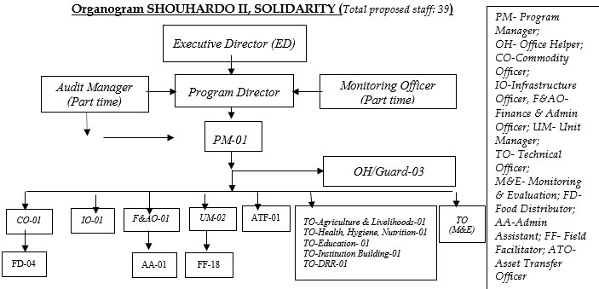
As per project design, SOLIDARITY has set-up one Program Office and two unit offices. The Program office at New town area, Kurigram along with one unit office and another unit office at pateswari village under Bhogdanga Union. All the office locations are finalized considering total o8 working unions of Kurigram Sdar Upazila also the distance and existing transportation system. . In order to accomplish the tasks of SHOUHARDO II Program, the organization hired a total of 39 staffs in set positions. The position wise staffing was shown in below Organogram:
In spite of the hierarchical staffing pattern, central management followed supportive supervision mainly through evidences-based feedback mechanism supported by PM&E findings on monthly basis along with weekly feedback to all level staffs from immediate supervisor. Each staffs were assigned with specific roles and responsibilities with reachable deadline. Besides, program management committee was formulated and was tried to make effective through meeting at regular interval. The program staffs attended SHOUHARDO II coordination meetings, such as SHOUHARDO II partner headed by CARE central offices and GO and NGO coordination meeting regularly at Upazila and district level. The NGO had proactive strategies of program risk mitigation, however on emergency crisis, the risk was solved collectively in collaboration with the community.

6. Program Achievements and Results:

SO-1: “Availability of” and “access to” nutritious food enhanced and protected for targeted households
The strategic objective -1 was mainly focused on two areas: i) improved and diversified agriculture systems developed and linked with private and public sectors and, ii) enhance income generating activities.
Efficient Diversified Agriculture Groups in Place:
Based on the applied wellbeing (WBI) assessment of this Program, The SOLIDARITY developed four occupational groups, namely Comprehensive Homestead Development (CHD), Agriculture, Fisheries and Income Generating Activities (IGA). All the groups were made efficient through capacity building on agriculture, fisheries and IGA sectors and input supports.

COG Training and Input support:
Basic and refreshers trainings were provided to the four core occupational groups, i.e. Agriculture, CHD, Fisheries and IGA on how to improve their respective occupation. Overall, the ratio of target to achieve on the training of COGs households was almost equal with a minor deviation on achievement. The achievement deviation was the result of flood and river erosion led displacement and migration, death, addressing duplication bias on counting target beneficiaries. This intervention hugely impacted for crop diversification and intensification that resulted increase production and consumption. 100% beneficiaries have received training before receiving input. Respective Government officials of DAE, DoL and DoF, technical partners and private sector actors actively participated in this capacity building training. Beneficiaries HHs were being practicing new technology and management practices thus increased production and income that ultimately contributed to reduce food insecurity. Also PEP HHs got market access and fair prices in case of input purchase and selling through involvement of private sector actors. This intervention also hugely impacted for crop diversification and intensification that resulted increase food production and consumption as well.

Enhancing Micro Enterprise Development for IGA:
To enhance micro enterprise development for IGA, a set of strategic activities has executed to strengthen microenterprise productivity. This accumulated effort was supposed to create a win-win situation for producers, business, and consumers. First, the beneficiaries were made aware about identifying quality inputs and registered dealer. Second, each producers group was tried to train on how to create value of their yields before sending to the market. Third, buyers and producers were introduced with each other that facilitated direct buying and selling bypassing middle men. Finally, the business persons were motivated, as a sense of responsibility, to make smooth market access for the poor. As a result, PEP HHs got market access and fair prices in case of input purchase and selling.

Demo plot establishment for technology transfer:
Demo plots establishment and maintaining including day observation was to transfer knowledge on how to adopt updated agriculture technologies and their efficiency. Finally, farmer’s field day was observed in presence of large gathering for wider dissemination of 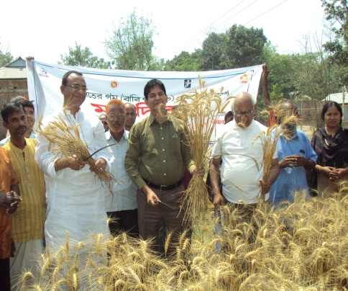knowledge covering 2000 – 2500 community people in each occasion and being on board with relevant govt., agriculture extension officer, representative of agriculture business persons, VDCs, community leader and local elected representatives. All these demonstrations of SHOUHARDO II Program helped in making mass awareness in the locality for its innovation and increased production. SHOUHARDO II farmers played vital role among PEP and non PEP farmers for extension these technologies as well as contributed remarkably in production, climate change adaptation that finally leads their food security.
Deputy Commissioner, Kurigram participated FFD at Proshadkalowa -, Kurigram; Photo: Sofiul Alam Mondol, TO-A&L, Date:

Technology Adoption and Diffusion by Collaborating Public and Private Sectors:
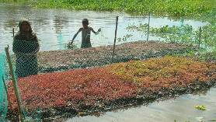To address climate change vulnerability SOLIDARITY-SHOUHARDO II Program facilitated to introduce new technology for beneficiaries in collaboration with other institutions/organizations of both public and private, namely CSISA-BD, IUCN, WorldFish, Bangladesh Rice Research Institute (BRRI), Bangladesh Institute of Nuclear Agriculture (BINA) and Chittagong Veterinary and Animal Science University (CVASU). Through these partnerships lists of improved technologies were introduced that covered modern crop varieties (rice, mustard, mug bean etc), climate smart technologies (floating garden, key hole garden etc), modern fisheries technologies etc. These interventions hugely impacted on human welfare irrespective of PEP & Non-PEP farmers. Beyond assurance of food security & economic solvency these demonstrations helped PEP HHs for enhancing food security, economic empowerment and increased social dignity as all these demonstrations contributed a positive revolution in this area for its innovation and increased production. All these are now replicating by both PEP and non PEP farmers as popular agricultural technology and contributing greatly in GDP. These interventions created a good image of CARE among the community and to the official of respective government department.
-Morseda; in front her floating vegetable bed at Dubariar Vita village , Kurigram, Photo: Debobroto ,ATFBokshi-, Dare: ------------

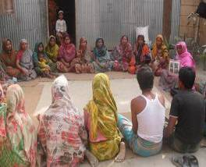Skill development initiatives for beneficiaries:
Knowledge transfer through Court Yard Session by CAV at Arajipolashbari , Kurigram, Photo: Jahangir Alom ,UM; Date: -22.5.2013
To make the effort sustain; SOLIDARITY-SHOUHARDO II Program has undertook initiatives for ongoing capacity building on agriculture and livelihoods issues. 58 trained Community Agriculture Volunteers were enraged to develop beneficiary’s technical capacity on regular basis. Regular court yard session, house to house visit, farmers learning visit, result demonstration etc were major initiatives to train farmers on modern agricultural and livelihoods related issues. This enhanced their knowledge on modern agricultural practices, networking building capacity and production availability which has felt great impact their daily food consumption pattern and daily income and family level decision making capacity especially for women.

Formation of Functional Saving Group:
SOLIDARITY SHOUHARDO II program facilitated to develop 29 self-help savings groups for promoting safety net necessity and welfare of the PEP households. Besides, accumulated savings were utilized for meeting the necessity of the group members and to make them free from the grip of the local money lenders and other exploitations. This intervention is also facilitated the target communities for exploring and involving in IGA for gaining economic empowerment through employment generation. Total number of saving group members were 803 and their accumulated saving was 5 lac 1 thousand 628 taka. Out this, a total of 4 lacs 35 thousand 577 take was used for safety net purpose, saving at bank 59 thousand 41 taka, and cash at hand 7 thousand 1o taka (updated up to January 2015. This hugely resulted to reduce PEP external money lender dependency time to time.

Accomplished Action Research:
Under the program two action researches were conducted: one on goat rearing and other on vermin compost preparation. First, the goats rearing experimentation was conducted on two villages. The experimental action research shows that the mortality and morbidity is comparatively very low in Suverkuti (who reared on platform basis) than Baraibari (who reared without platform. Second, preparation and use of vermin compost resulted more beneficial in terms of yield and cost-effectiveness compared to traditional chemical based cultivation. A total 20 plots (2 plots per each HHs) of vermin compost was supported both technically and financially from SOLIDARITY. At same time utilization of vermin compost were sensitized to other community members. As a result a total of 10 CHD HHs and beyond prepared vermin compost bed for their agricultural production and used their vegetables garden which has improved production quantity and safe money. Findings from this pilot initiative could be used for further livestock and fertilizer management in crop production.
In fact, SOLIDARITY SHOUHARDO II Program had reached to its all 100% beneficiaries through this SO with training and input support over the program period. Interventions under this SO hugely impacted for crop diversification and intensification that increased food production and consumption of PEP as well.

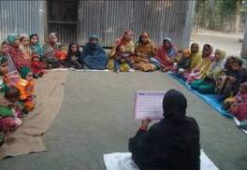SO-2: Improved health, hygiene and nutrition status of 1, 76,706 children under 2 years of age
Court yard session at Pateshawry village Kurigram Sadar Photo: Shahanaj TO -HHN, SOLIDARITY,Kurigram

The Strategic Objective-2 mainly focused on improve health hygiene & nutrition status of 1,76,706 children under 2 years of age. To achieve this objective SOLIDARITY SHOUHADRO II program has accomplished a series of activities during the program period such as; referral linkage workshops at district and upazila with health and family planning departments, coordination meeting, joint field visit of health family Planning officials, relevant Day observance joint collaboration with govt. and others NGOs, regularly conducted Growth Monitoring & Promotion (GMP) session, Courtyard session & counseling at household level. Major achievements were:-

6.2.1) Promotion of Maternal and Child Health (MCH) through awareness raising on health hygiene and nutrition among beneficiaries:
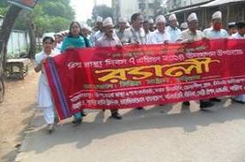To increase knowledge and awareness on health hygiene and nutrition among beneficiaries SOLIDARITY had facilitated courtyard session among mothers, Growth Monitoring and Promoting (GMP) session, mother to mother support group meeting, and ECCD parenting session on wash especially hand washing, national day observance, counseling through household visit. During the program period a total of 6668 community health volunteers (CHV).Through CY session increased health hygiene & nutrition knowledge & awareness program beneficiaries, they are practicing hand washing at six critical moments, drinking safe water, and using sanitary latrine. Mothers are practicing ANC during pregnancy, iron tablet receiving during pregnancy and lactation period, timely immunizing their children, hand washing practice increased among the beneficiaries. As a result, child immunization rate increased pre and/or post natal complication, disease prevalence especially water borne disease reduced which reduced child mortality.
Rally on World health day on 7th April 2014 at Kurigram Sadar, Photo: Shahanaj TO-HHN , SOLIDARITY

The program conducted Growth Monitoring & Promotion (GMP) session among pregnant women and lactating mother of under 2 years children on regular (monthly) basis. A total of 6507 Growth Monitoring and Promotion session conducted during program period. Through GMP session mothers and caregivers informed and realized their children’s growth status & taken proper initiatives (feeding and care) in time. As a result child health and nutrition status improved significantly.

SOLIDARITY SHOUHARDO II program also observed relevant days world breast feeding week, vitamin-A campaign, World Health Day, Global Hand washing day joint collaboration with govt, H&FP department, community members, VDC, EKATA, PIC, local government representatives both at union and district level Through these event people become sensitized and stimulated health and other relevant service providers and promoted well being, healthy life of people.
Community managed cooking and feeding demonstration (hotchpotch demonstration) arranged regular basis at all working villages which positively changed knowledge and practices of mothers and caregivers of children on infant and young child feeding (IYCF). As a result child nutrition status improved among the community.
To boost up the hand washing practices the program conducted wash related session focused on hand washing demonstration session at Early Childhood Care and Development (ECCD) students and ECCD parenting meeting. As a result, ECCD students and their parents learnt more & sensitized about WASH issues & practicing hand washing at six critical moments, drinking safe water, and sanitary use accordingly

Establish linkage with Health Service Providers (Govt. Health and Family Planning department and other NGOs health service providers):
The SOLIDARITY SHOUHARDO II program had taken many initiatives to establish linkage with Health Service Providers (Govt. H&FP and other NGO health service providers like Govt. Health and Family Planning at others NGOs at Upazila and District level. To strengthen referral linkages with govt. H&FP department for creation of easy access and smoothly getting services by beneficiaries program organized and conducted district and upazila level referral linkage workshops with Health and Family Planning Department , 4 Review workshop with upazila H&FP department, 48 half yearly coordination meeting, 13 joint field visit of District & Upazila level Health and Family planning officials at the program site for service availability and accessibility and necessary support to ensure treatment support to the PEP. Through these initiatives Health Service Providers has been more sensitized and an effective Linkages established with the community people and Health Service Providers like District Sadar Hospital, Maternal and child welfare centre(MCWC) union level health centre ,community clinics etc and other NGO health service providers. As a result poor &extreme poor beneficiaries started to receive health services easily from nearest health service providers which increased ANC/PNC including other health service receiving rate, reduced disease prevalence, low birth weight children, and improved child health and nutrition status as well as reduced child and maternal mortality rate.
SOLIDARITY SHOUHARDO II program also implemented Community based management of Childhood Illness (C-IMCI) and Community based Management of Acute Malnutrition (C-MAM) in selective 4 unions as pilot basis. Under CMAM initiative Severe Acute Malnutrition(SAM) children/ patient (under 2 years) screened and referred to Sadar hospital Kurigram, TDH nutrition specialized hospital for treatment and increased home based care of Moderate Acute malnutrition(MAM) children after necessary treatment. In addition, awareness raising session conducted in respective villages and provided close monitoring and follow up of SAM and MAM children. As a result, mal nutrition reduced significantly among the community.

Tube Wells Maintenance/Installation and Household Latrines: A total of 414 sets (5-ring & 1-slab in each set) HH Latrines were provided to the PEP HHs and 147-Tube well platforms were constructed to improve the access to safe drinking water and sanitation to the PEP as well as community peoples. As a result, overall health hygiene status in the community has been improved as well as water borne diseases were reduced in the community.

Arsenic test of tube well water: A total of 9237 nos. tube well water owned by PEP households were tested in order to determine arsenic contamination at 49 villages under Kurigram Sadar Upazila. After completion of field test and laboratory test, out of this a total of 305 nos. tube wells are marked by RED color due to having arsenic contamination beyond tolerable limit. Also the community people became aware of arsenic safe water through participation in Arsenic awareness campaign.

SO – 3: PEP Women and Adolescent Girls Empowered in their Families, Communities, and Union Parishod
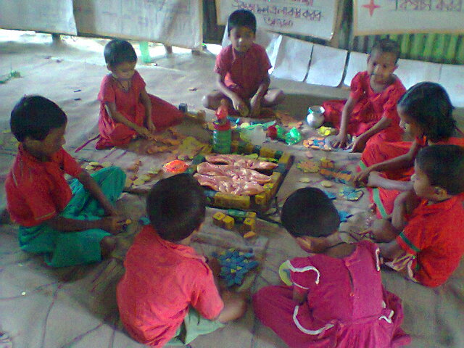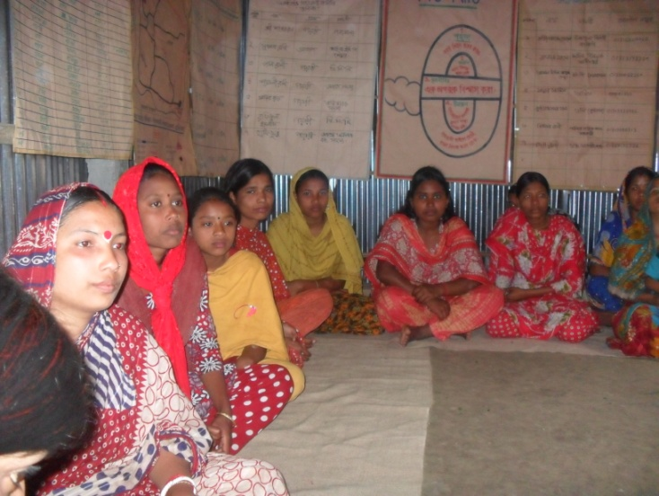The EKATA group has developed and functioned to enhance decision making capacity and dignity of women and adolescent girl. A total of 700 women and adolescent girls have affiliated with a total of 20 EKATA groups. Each group consists of 35 women (20 women and 15 adolescent girls) and each EKATA groups have used a permanent premise (voluntarily provided by the community), where conducted regular sessions 4 days in a week on different women empowerment issues by EKATA volunteer. Program has organized training, refreshers, quarterly learning sharing meeting, cross visits for those EKATA volunteers. Also established 20 community library in each EKATA groups where have different types of books on women rights, violence against women, domestic violence law etc. SOLIDARITY also has formed 32 empowerment groups in 32 non EKATA villages participation of VDC, COG, MCHN group, adolescents etc. These empowerment groups have monthly organized awareness session on different social issues as well as women rights and empowerment issues, organized leadership training for EKATA group members. Through these activities, enhanced awareness on their rights, decision making ability in their family as well as community, communicate with different GO/NGOs and received different services i.e. VDG/VDF-76, old age allowance-03, widow allowance-04, maternal allowance-16, swomen were involved in 100 days work scheme-26. With these, violence against women were reduced remarkably than before through conduct different session, exercise violence tree, cost of violence etc. During the reporting period, EKATA groups have prevented 07 early marriages, reconciled 10 family conflicts. Re-admitted 127 drop out adolescent girls in different schools and ensured legal aid support for 2 women through legal aid institutions. 14 EKATA groups have build linkage with Women Affairs department, BRAC and other service providers to continue their activities.
During ECCD session children are playing at ECCD center, Kurigram, Photo: Fawzia, TO-Emp, SOLIDARITY

EKATA women and adolescent girls participated in regular session, Kurigram. Photo: - Mani Mistry, TO-Emp, Date:

A total of 26 ECCD centers have been established for developed children mental, physical and social development following standard ECCD guideline. A total of 2853 children (boys 1355 and girls1498) enrolled in nearby primary school. Capacity building training, refreshers, cross visit, learning sharing meeting for ECCD volunteers have been organized as program plan. To enhanced capability of A total of 2853 ECCD children enrolled in different primary school. Annual sport, art and craft competition has been organized for in ECCD every year. Now, 6 ECCD centers have continuing by ECCD management committee and VDC. Program has assisted to receive primary books and learning materials from department of primary education.

During the program period 8 EVAW forum have been formed in 8 unions. Capacity building training have been organized for EVAW forum members to enhance their capacity and worked with Union Parishad NNPC as a coordinative manner. As a result, EVAW forum contributed to reduce violence against women in the SHOU II program area. Coordination meeting with Union Parishad NNPC has held regularly. Program has organized couple sessions, youth campaign with women, male counterpart, community youth, different likeminded organizations, GoB officials etc. These events have helped to women to reduce family level violence as well as enhance women empowerment. Male were also participated in household level workload. Union and Upazila level interactive discussion session with religious leader, local likeminded institutions, Union Parishad, medical, legal institution etc. Through these meetings, women were gained capacity to communicate with those institutions and received different services. As a result, PEP women were received VGD/VGF-76, widow allowance-4, old age allowance-3, maternity allowance-16 and 26 women were involved in 100 days work scheme.

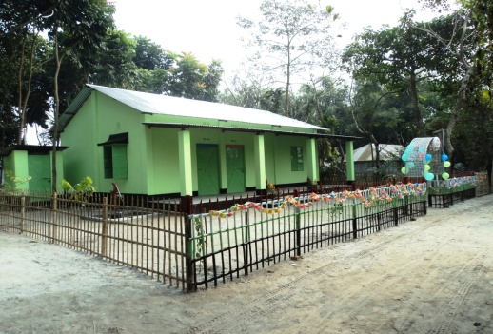Construction of Community Resource Centre (CRC): 05-Community Resource Centres (CRCs) have constructed at different SHOUHARDO II communities to increase the opportunities of VDC meeting, community gathering and one stop service centre of different GO/NGO LSPs. Now these CRCs are being used for multi-purpose issues as office of the VDCs, operations of ECCD & EKATA groups. In addition, respective communities are being using these CRCs for social gathering, sheltering during floods and one stop service centres by different GO/NGO service providers.
Construction of CRC at Madhabram Village under Kurigram Sadar UZ Photo-Ali Hossain (IO)

SO-4: Local Elected Bodies and Government Service Providers Responsiveness and Accountability to the PEP Increased
To turn local elected bodies and government service provider more responsive and accountable to the poor and extreme poor friendly, the SOLIDARITY had undertaken the following diverse concerted efforts. Accomplishment of all designed activities was 100%, appraisingly capacity building training for diverse stakeholders was over achieved.

Formation of Functional Village Development Committee (VDC):
A total 49 VDCs with a total 735 members was developed and functioned to overall success of SHOUHARDO II program. Their capacity was enhanced through trainings (Citizen Charter, Leadership development etc.), meeting, workshop and cross visit. A regular coordination meeting was held on monthly basis to facilitate the prioritized agendas to be implemented successfully with SHOUHARDO II staffs. The VDC was formally linked with UP facilitating their annual planning including budget and collaborated development works. So far, the VDC mapped out local resources, problems, causes and solution, and community action plan and its review. Apart from facilitating UP’s and SHOUHARDO II works, they had their agenda specific development initiative. As a result, the VDC had become a catalyst for changing of their own village.

Service provisioning through Service Campaign:
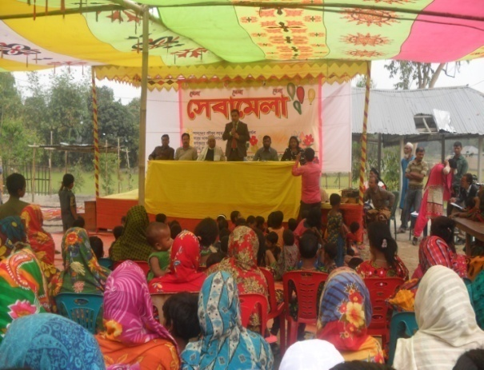
In the program period SOLIDARITY organized 6 numbers of Service Campaign at remote union of Kurigram Sadar upazilla. In the service campaign numbers of GoB & NGOs service department participated through stall in the service campaign. There was huge number of beneficiaries were participated in the service fair. Upazila Chairman, Upazila Vice Chairman, Upazila Mahila Vice Chairman, Primary Education Officer, Secondary Education Officer, Upazila Family Planning Officer, Upazila Agriculture Officer & Heath complex representative were present in the service fair. Through these fair; community aware about the service of the GoB service providers. As a result the community people communicated to the service providers for their services.
Service Fair at Gobindopur ,Photo: Mahfuza Akter ,TO (IB)

Making PEP friendly Service Delivery of Union Parishod:
The SOLIDARITY conducted training for the elected UP representative and officials on “Ensuring Food Security for the PEP”. Appreciating to learn that UNO, DDLG, UAO, UFO, DLO, DDA, UH & FPO were attended as resource persons and invited guest. Besides, the SOLIDARITY oriented UP officials on how to assess UPs performance using MSS tools in order to reflecting quality and transparency of their roles and responsibilities.

SOLIDARITY also provided two days long training to the 48 PEP (who co-opted as members of different standing committee of UP) to facilitated meaningful participation in UP service deliver, and surveillance. A total of 16 learning and reflexive session with different batches were held with elected representative of UP. Also SOLIDARITY arranged learning visit for 106 participants to know successful role of PEP member into Union Parishod in JSKS Demla and BDSC Bhurungamari area.

Through these initiatives, PEP became aware about various UP service delivery activities and strengthened bargaining capacity to get services and accountability increased of NBDs and LEBs. Moreover, the participants were learnt their entitlement and different services of UP, NBDs, LEBs & others service providers. As a result, both demand and supply side became aware about their services & responsibility & made a new bondage among them. Accountability of service providers have increased remarkably and PEP had received necessary services as they demand.

Cash for work (CFW): These interventions contributed directly on livelihood security through employment opportunities during the lean period. The PEP beneficiaries were engaged in Cash for work (CFW) as labor force and received wages in cash directly against their work. During the reporting period a total of 50-Homestead plinths and 05-Community ground raising have been developed through Cash for Work (CFW) where employment generation opportunities for the PEPs have been created during lean period. As results, food security, social dignities of the targeted PEPs have been increased and migrations have been reduced accordingly. During the last flood peoples took shelter on their raised homesteads (HS) with their cattle, poultry etc. and saved their valuable assets during flood without any shifting. They have continuing cultivation of different varieties of vegetables on their raised HS premises to meet their nutritional requirements.

SO 5: Targeted community members and government institutions are better prepared for, mitigate, and respond to disasters and adapt to climate change
All most all the year people of Kurigram Sadar Upazila have been experiencing flood sufferings. The topography, location and outfall of the river Dharla and Brahamoputra shapes Kurigram Sadar Upazila is a flood prone area. Most of the year extreme events of flood adversely affected almost every sector, especially on economy, food security and poverty of the program areas of Kurigram Sadar Upazila. Under In flood management, Solidarity team of S HOUHARDO II programs has been implemented structural and non-structural measures. Targeted all disaster and climate risk management related activities categorized under two program elements. Those program elements were Capacity Building Preparedness and Planning (CBPP) and Assistance and Recovery. Solidarity accomplished all the activities as per plan.
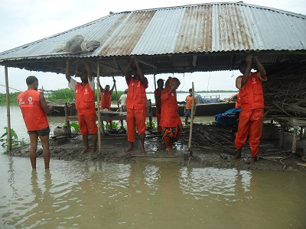Institutional Capacity Building of Union Disaster Management Committee (UDMC) and UzDMC: Diversified events have been accomplished aiming to enhanced capacity building on disaster management of UzDMC and UDMCs. Training conduction were the important capacity building events for Upazila Disaster Management Committee (UzDMC) and Union Disaster Management Committee (UDMC) members. A total of 08 batches training were held and covered total 257 no participants (male-214, female-43) of 8 UDMCs. As UDMCs are the grass root level government institutions, so priority have been given to build their capacity by assisting Risk and Resource (R&R) map preparation, develop and yearly basis review of Union disaster management plan (UDMP) of 8 Unions, Provided Early Warning, Search & Rescue (SAR) Equipments, observance of National Disaster Preparedness Day (NDPD), International Day for Disaster Reduction (IDDR) and simulation. Community level skilled human resources are an integral part of disaster management, especially for emergency response. Considering the essentialities Union level Disaster Volunteer (UDV) has been developed in all the Unions of Kurigram Sadar Upazila. A total of 288 UDV has been developed by training, learning sharing meeting, cross visit and engagement with different DCRM activities like R&R map preparation, NDPD and IDDR celebration and emergency response. Solidarity team also assisted to develop 49 Village level contingency plans as a part of community’s disaster response capacity building.
Union Disaster Volunteers are rescuing a river erosion threaten family of Panchgasi Union, Photo taken by Zannati, dated August 6, 2014

Last couple of years most of the Unions Parishad have been given emphasis and included disaster risk reduction activities at Unions yearly development plans. It has been observed that Union and Upazila DMCs were played proactive role to take all sorts of initiatives to assists vulnerable people. During the north-west Flood_2014 a total of 281 households were rescued by the direct assistance of UDMC and UDVs. Besides search and rescue UDVs have been worked with UDMC and Solidarity staffs as an additional force during emergency response activities like flood damage assessment, participant’s selection, food, non-food and WASH items distribution.

Organizational Capacity Building on Emergency Response:
SHOUHARDO II Program has been taken an initiative to build partners capacity building on disaster and climate risk management (DCRM). A total of 28 mid and senior level staffs (male-17, female-11) were participated in training on ‘Emergency Preparedness Plan (EPP)’. After the training Solidarity has been formed their organizational Emergency Response Team (ERT) and developed EPP. Developed EPP was used as base of last flood NW_2014 for emergency response.

Community Capacity Building on DCRM: All 49 villages have been covered by mass awareness activities on disaster and climate risk management issues, especially on household level preparation for disaster risk reduction over the program period. The awareness activities were drama, song, mock drill, community level national disaster day celebration and information sharing session at different community level forum like VDC meeting, EKATA and court yard session of mothers/farmers. As a result household’s members are taking necessary precautions to face disaster. Last couple of years household’s level asset losses remarkable reduced and reduced dependency outside assistance during emergency. Besides these UDMCs more efficiently managed early warning and search and rescue during emergencies.
Pilot and new initiatives on DCRM: Within the program period one pilot and two new initiatives also been taken to bring more diversity of disaster and climate risk management initiatives. The new initiatives were keyhole garden establishment at flood prone communities and Improve stove distribution. The pilot initiatives were School Based Teen Aged Brigade (SBTB) formation and skilled the members on disaster management another pilot initiatives was ‘Flood Forecasting and Early Warning System’. Both the activities impacted positively for disaster risk reduction. SBTB members acted as an educator of their families on disaster management that ultimately enhanced household level preparedness to reduce disaster risks. Flood Forecasting and Early Warning System’ initiative also have positive impact on institutional, community and households level disaster management related decisions. As a result households level disaster sufferings and losses reduced significantly in the pilot areas.
During the program period a total of 40 Keyhole Gardens have been established. The established gardens ensured year round households level vegetables availability to meet their family needs. Another initiative was to make mass awareness on efficient fuel wood consumption. Besides awareness rising 400 efficient fuel consuming improve stoves has been distributed among the program beneficiaries. Orientation on maintenance and appropriate use of improve stove also been given to all the users. The user’s saves fuel woods, reduced inhalation problems, kept clean of their kitchen and reduced risk of fire. Reduced fuel wood use ultimately reduced carbon emission and pressure on forest.

School Maintenance/Flood Shelters, RCC Culverts/U-drains and Rural Market development: 07-School Maintenance/renovation, 04-RCC Box Cculverts/U-drains and 03- Flood Shelters have been constructed/ developed. Education facilities as well as shelter opportunities during flood with user friendly environments have been created. As a result attendance & interest of students with quality education have been increased to the schools. At the same time peoples took shelters at these institutes during last flood. By the construction of RCC Culverts/U-drains a continuous road communication for the community have been developed and helped in establishing better communication and supported for accessing to market. As a result transportation & marketing facilities for agriculture products of rural PEP have improved through these schemes. Medical facilities have also been increased for the peoples (especially pregnant women) due to easy road communication.

7. Commodity Distribution and Management:

Coverage | July 2011 to November 2014
 | Commodity Distributed (MTs) |  |  |  | Number Achieved
 | Wheat | Veg. Oil | Peas | Total | Total no. of PLW | No. of Rations
MCHN Area | 897.290 | 89.729 | 44.865 | 1031.884 | 4862 | 89729
PM2A Area | 235.450 | 23.545 | 11.772 | 270.767 | 1280 | 23545
Total | 1132.740 | 113.274 | 56.637 | 1302.651 | 6142 | 113274
Commodity distribution and management was one of the major activities of SHOUHARDO II Program. SOLIDARITY has distributed food ration to the eligible food ration beneficiaries for the period from July 2011 to November 2014. Each food ration beneficiaries got food ration containing of Wheat-10.00 Kg., Vegetable Oil-1.00 Kg. and Yellow Split Peas-0.50 Kg. in every month. Total 1,302.651 MTs food commodity were distributed among 6,142 food ration beneficiaries during this period. Eligible Pregnant Women and Lactating Mothers with children under two years of age got the food ration support.

The LOA targeted food ration beneficiaries were 5,693 but achieved 6,142 which are 449 over achieved than the targeted food ration beneficiaries. With the involvement of VDC and community peoples formed village and FDP level Program Implementation Committee as well as oriented them on food commodity management and distribution for smooth management and distribution of food commodity. In each month carried out addition/deletion/shifting of the food ration beneficiaries. Conducted pre-distribution and post distribution meeting in each month at each FDP and executed food commodity distribution work.

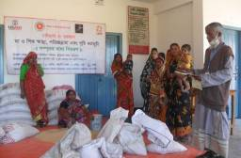Faced challenges in commodity distribution due to remoteness, variability of river erosion and flood. It was very difficult to ensure presence of 100% ration recipients/nominees at FDP in every month. Also, country wide political unrest situation was very challenging for commodity distribution. It is recommended to consider the Food Distribution Point to keep in mind the geographical condition and remoteness of villages. Packet system commodity distribution may be introduced. It is recommended to affix photo of the food ration beneficiary and nominee on the Ration Card for easy identification. Finally, double ration system should be discontinued.
Commodity distribution at Belgacha UP FDP, Date: 11/05/14, Photo taken by: Kalpona-CO

8. Program Exit and Sustainability:

According to the principals of the SHOUHARDO II program, SOLIDARITY had tried to build up capacity of the VDCs, EKATA groups, COG participants, ECCDMC, EVAW committee, PIC, and UDMC and so on, to continue to reduce vulnerability to food insecurity during the entire program life span. At the eve of the phase out, according to exit Plan we were conduct meeting and made up adequately aware and shared the achievements and hand over all documents and responsibilities to all relevant VDCs, COG groups, EKATA, savings group, ECCD management committee at total 49 nos. community and after completing village level exit meeting facilitated 5 nos Union level exit meeting and hand over all village level exit documents and facilitated District level exit meeting with Health department but according to village categorization solidarity completed village level 49 nos exit meeting and 5 nos Union level exit meeting but did not facilitate 3 nos Union and one Upazila level exit meeting but hand over behind Union exit all document to CARE management.
At this moment a total of 49 VDCs was established and made functional with constitution, strategic planning, formal linkage with govt. and private business agencies, and adequately trained resources. Moreover, we handed down continuation of SHOUHARDO II program activities with relevant document to the VDC and EKATA. Concerning to the financial issues, we tried to make Union Parishod and Upazilla Parishod obliged to allocate funds for successful execution of the activities from their annual development budget. At the same time, formation of functional saving groups would also facilitate their own activities. At individual level, we had tried to make beneficiaries aware, confident and experienced dealing with different shock to restore their resilient livelihoods.
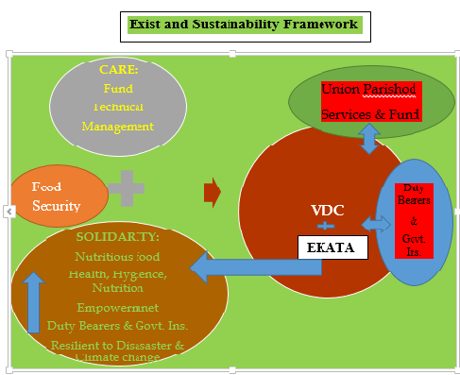
Independent planning, access to information, legal support and justice, modern agriculture related training and motivation activities have a direct impact to achieve these goals. The program has tried to create the community members to be self-dependent as if the objectives of the program continue even after the program stopped. To do this, the program has emphasized on capacity building.
At first, the program run awareness building activities and provided training and economic support to the beneficiaries. Then monitor the effectiveness of the economic support at field level. Gradually decrease the direct support to the beneficiaries and in the meantime they have gained confidence and continuing their livelihood smoothly. To be specific, our endeavor was to provide basic training on agriculture and agriculture based value chain, nutritious food, child and mother nutrition, health water and hygiene, leadership and life skills of women and adolescent girls, supportive role of Union and Upazila Parishod and also relevant duty bearers, and finally disaster risk reduction and adaptation to climate change vulnerability.
Secondly, we tried to transfer assets, i.e. commodity support and agriculture inputs. Finally, infrastructure and maintenance supports were also provided to ensure smooth life and livelihood. All the strategic activities were accomplished with diverse VDCs collaboration resulting enhanced capacity of the VDCs.
Concerning to mainstreaming, The SOLIDARITY, as implementing partner of SHOUHARDO II program has got new vision with strategic result-driven implementation framework and trained officials. As evident, the management has developed some new development proposal following SHOUHARDO II program approach. Finally, the organization has revised its policy relating management, financial and procurement, M&E system, Gender, community centered development activities.
To the end, the organization has still committed to provide technical support as required from the VDCs to reduce vulnerability to food insecurity. And also we declare our earnest desire to work as partner with CARE in other programs and USAID funded food security program next phase if extended.

9. Financial Information:
During the agreement period we received fund from CARE amounting to Tk.140,036,124 against the approved budget Tk.140,849,179 and total expenses was Tk. 140,023,963. The financial progress e.g. fund utilization rate was 99.41%. SOLIDARITY has successfully completed all the planned activities following donor compliances within timeframe and utilizes resources effectively and efficiently with minimum observations. The fund utilization status over the period is as below:
Period | Budget (BDT) | Expenditure (BDT) | Utilization rate (%) | Remarks
March 2011 to September 2011 | 10,709,684 | 10,709,684 | 100
October 2011 to May 2012 | 24,670,916 | 24,670,916 | 100
June 2012 to May 2013 | 32,566,003 | 32,565,353 | 100
June 2013 to May 2014 | 36,225,443 | 36,225,370 | 100
June 2014 to February 2015 | 36,677,133 | 35,852,640 | 98 | Exp. as of 16th Feb. 2015
Total | 1 40,849,179 | 140,023,963 | 99

During SHOUHARDO II Program implementation period SOLIDARITY has gained hands on experience on transparent financial management. In line with organizational financial and accounts manual, SOLIDARITY tried to comply with guidelines and instructions of CARE authority to ensure transparent and effective financial management. In order to ensure financial compliance, there was an adequate supports from Grants team, Partner’s Expenses Certification Team (PECT) and Regional Management team.
SOLIDARITY has faced A 133 and ADS 591 audits and it was our pleasure to face those audits with very negligible findings. Based on their findings, the organization tried to provide necessary responses and successfully complied with need based corrections. These audits obviously improved our knowledge and skills to the system of USAID compliance.
During this period SOLIDARITY have faced different challenges like frequent dropout of key staff and volunteer, delay in receiving fund from CARE and multi fund use for different purposes. SOLIDARITY have also overcome those challenges making contingency plan and even worked in extra time. The overall financial management of SHOUHARDO II Program is excellent. SOLIDARITY has efficiently managed the fund and other resources like FF&E, vehicles etc. with the support of CARE Regional Management Team and by establishing strong financial monitoring, capacitate staff through formal training, on job training and effective coordination with SOLIDARITY and CARE.

10. Challenges and Lessons Learnt:
Overall Challenges:
- Disaster induced forced displacement and migration posed barriers to reaching out 100% COG training and input support distribution.
- Multiple input support to single beneficiary.
- Land for CRC construction.
- To enhance livelihood diversities where poor control of resources (land) by the poor.
- Political unrest hampered regular program activities.
Lessons Learned:
- The program design teaches how to make community as catalyst for change by promoting and collaborative efforts of VDCs in every stage of program implementation.
- The program shows the pathways of utilizing duty bearers and govt. institutions.
- Reaching a particular goal i.e. reducing vulnerability to food insecurity required a comprehensive consorted efforts relating to underlying causes of food insecurity.
- EKATA has become an icon of women and adolescent girls centered development. In addition, establishment of ECCD would be good future investment for betterment of the country in future.

11. Conclusions:
During the life span of SHOUHARDO II program, the SOLIDARITY covered the target population and accomplished program activities successfully and quality. Due to implementation of planned activities during last 4 years an immense result is observed visible in project areas. It was observed by different stakeholders that the program did very well in reducing vulnerabilities of poor and extreme poor in regards to food security. From the midterm evaluation and present observation indicated that more households are now proactively able to ensured food security at household level than earlier. The program tried to build improved and diversified agricultural technological developed as a result short and disaster tolerant varieties are popularly accepted by the community people irrespective of class and increased production. The overall scenario of health, hygiene and nutrition status of the children under 2 years of age and the mothers was presumed to be relatively improved. Community beneficiaries are more knowledgeable in dealing with HHN issues and receiving better services from govt. health service providing agencies. The targeted community people have made tremendous progress in education, women empowerment, reduction in VAW, linkage building, strengthening rights and entitlements etc. Due to linkage building and networking better accesses of PEP ensured to LEB and service providing departments and they are also providing proactive supports to PEP. Finally it can be says that SOLIDARITY has gained so many invaluable learning and experiences that could be used in future in formulating new projects and/or implementing ongoing projects with quality that ultimately benefits the poor in their wellbeing.

